MEMORANDUM

TO: Dena Pollard
Mobile County Commission Public Relations

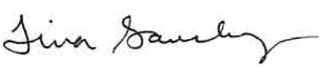
FROM: Tina Sanchez
Environmental Services Director

DATE: July 30, 2026

______________________________________________________________________________

Pursuant to the Open Meetings Act, please notify the news media of the following changes:

- The Mobile County Solid Waste Disposal Authority cancelled the meeting scheduled for Wednesday, August 12, 2026 @ 11 a.m. in the Mobile County Environmental Services conference room on the Seventh Floor, South Tower.

If you have any questions, please advise.

